Management Science Best Paper Award in Marketing
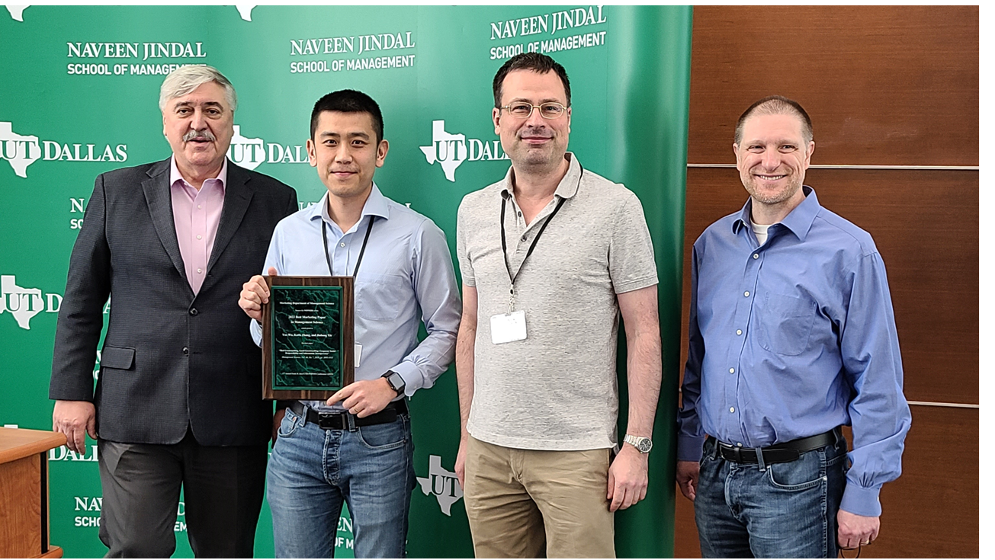
The Winner
- Yue Wu, Kaifu Zhang and Jinhong Xie (2020), “Bad Greenwashing, Good Greenwashing: Corporate Social Responsibility and Information Transparency”, Management Science, 66(7), 3095-3112.

Finalists (in chronological order by publication date):
- Bryan Bollinger and Wesley Hartmann (2020), “Information vs. Automation and Implications for Dynamic Pricing,” Management Science, 66(1), 290-314.
- Zhijun Chen, Chongwoo Choe, and Noriaki Matsushima (2020), “Competitive Personalized Pricing,” Management Science, 66(9), 4003-4023.
- Avery Haviv, Yufeng Huang and Nan Li (2020), “Intertemporal Demand Spillover Effects on Video Game Platforms,” Management Science, 66(10), 4788-4807.

